Best Practice Analyzer (BPA) in Tabular Editor

1. Introduction
Best Practice Analyzer (BPA) is a feature in Tabular Editor used to validate tabular models against a set of predefined or custom rules. It helps enforce modeling standards, improve performance, and maintain consistency across Power BI, SSAS, and Fabric semantic models.

2. Key Features
- Rule-based validation
- Custom rule creation
- Automatic fixes using FixExpression
- Severity levels (Info, Warning, Error)
- Integration with CI/CD pipelines

3. Example Rule: Key Columns Should Be Hidden
This rule ensures that columns marked as keys are hidden from end users.
Expression: IsKey && !IsHidden
FixExpression: IsHidden = true

4. How to Run BPA Validation
Step 1: Open your model in Tabular Editor
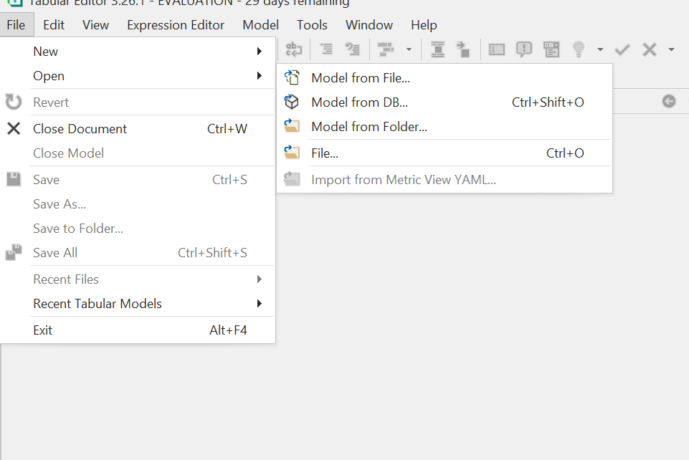
Step 2: Navigate to View → Best Practice Analyzer
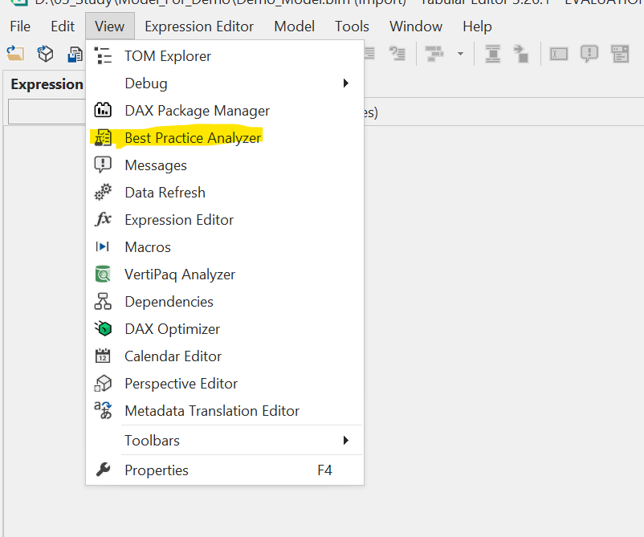
Step 3: Click "Run Best Practice Analyzer"
Step 4: Review violations and apply fixes if needed
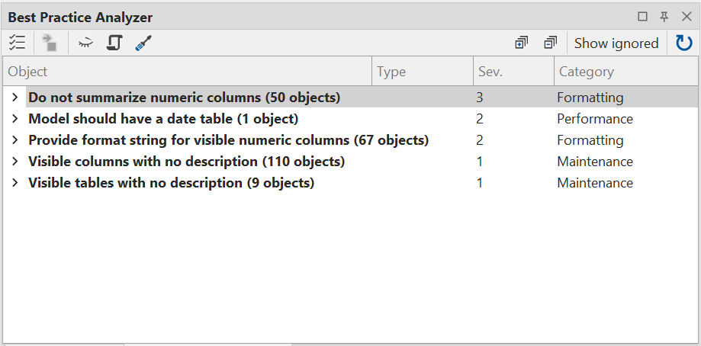

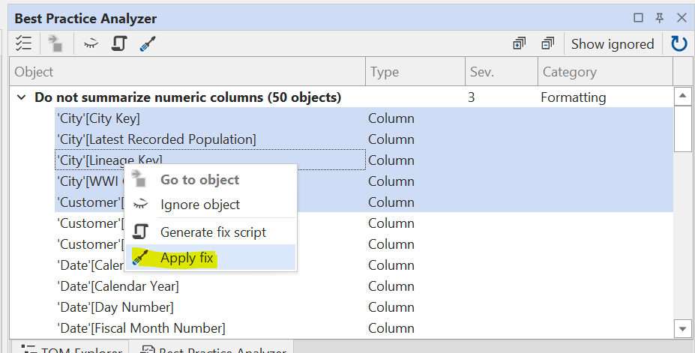

5. Automating BPA
You can automate BPA using:
- Run on Save (Preferences)
- Command Line Interface (CLI)
- CI/CD pipelines for deployment validation

Using C# Script for Description updates

1. Introduction
C# scripting in Tabular Editor enables quick and efficient updates to model descriptions, helping provide a clear and consistent glossary for end users. This improves overall model understanding and makes it easier for users to adopt and work with the data.

2. Key Features
- Dynamically reads data from csv
- Looks up tablenames, column names , measures and updates the descriptions

3. How to run C# scripts
Step 1: generate a CSV file containing the tablename, columnnames and the relevant descriptions
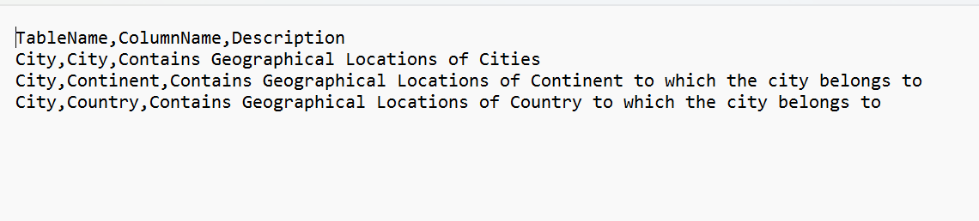
Step 2 :
Import the C# script into the tabular editor:
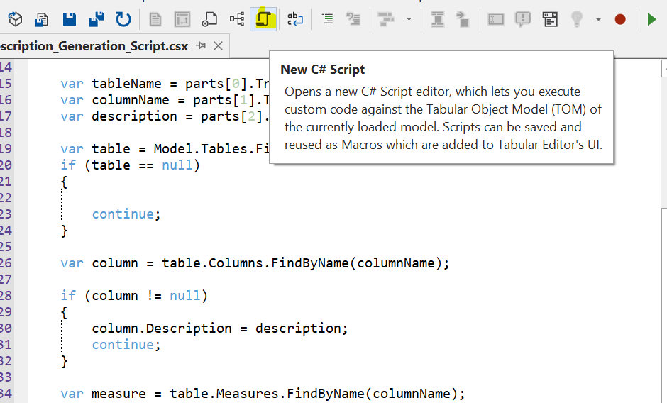

Step 3: Execute the C# Script to update column names and measures. Kindly note same will be visible in Power BI as well.
